The DIRT DRAinaGe RACE
Soil Infiltration Test
Charley Schwartz, PE
(July 2014)

Materials @ Each Soil Test Station | Shared Materials
- Soil Sample bucket  - Drip Bucket  - Soil Test Bowl  - Water Bottle (500 mL or 16.9 oz)  - Soil Dump Bucket (optional)  - Soil Shovel (can also be shared) | - Coffee Filters  - Filter Fabric (coffee filters will also work)  - Stopwatch  - Log book (to record observed times)  - Water Reservoir (to fill water bottles & wet filters)  - Water Dump Bucket (to drain all Drip Buckets)  - Prediction coins/tokens/markers (optional)

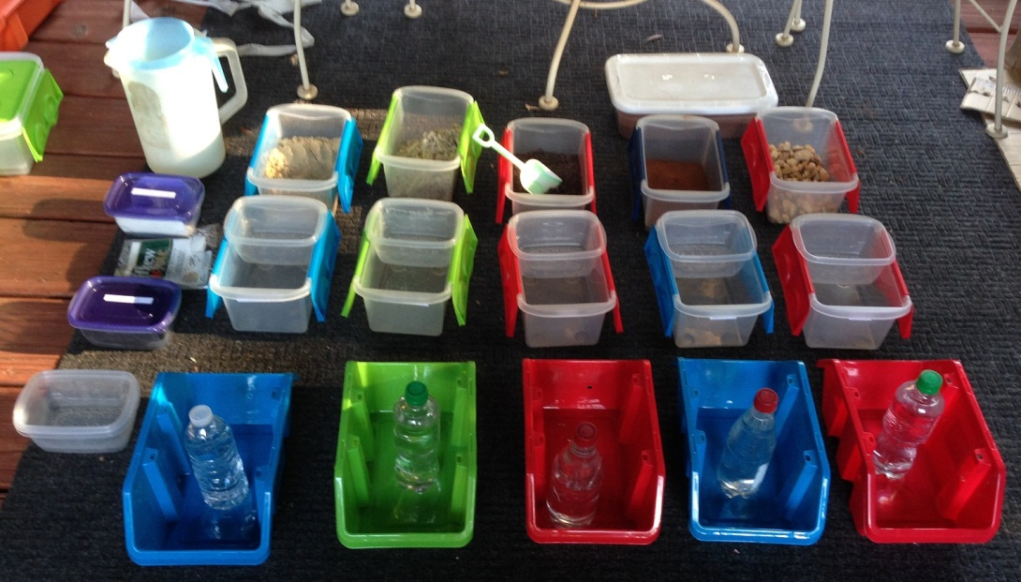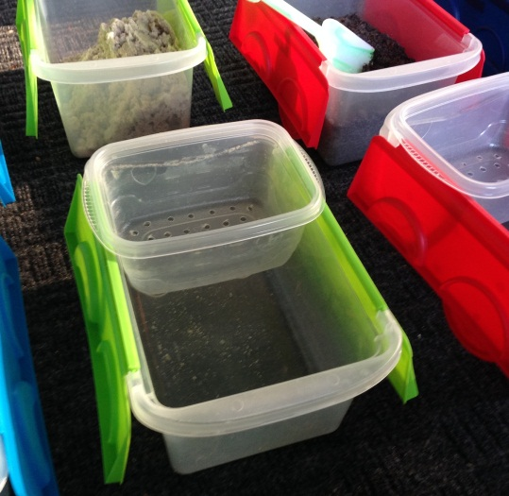

Preparation: Drill 36 holes (13/64” diameter) into bottom of Soil Bowl (Evenly distribute holes)
Pre-Cut Coffee Filters to fit bottom of bowl (Slightly oversize so entire bowl bottom covered)
Pre-Cut Filter Fabric (Large enough to cover soils as water poured)
Find Soils to be tested (ex. Hardware store, yard, etc.)

Tips:
- Have a log book and record each Tester’s race result (Soil Test Category > Name & Observed Time). Scientists can then compare their results to other testers. Are they consistent? What is the range of results?
- Prefill lots of 16 oz water bottles. Keep large reservoir handy.
- Insert coffee filters into soil test bowls for the testers (this can be tricky, but some might enjoy it)
- Keeping Time (Alternatives)
  - One person can serve as THE TIMEKEEPER, while testers observe 1-2 stations. TIME KEEPER says “start” and testers pour. Testers call out soil name (ex. Gravel Done!) when water disappears and timekeeper calls out and records the time.
  - Multiple stopwatches may be used (one at each test station).
  - No watch. Just pour water on soils at same time and observe race to see which drains 1st, 2nd …
- Clean-up
  - Dump drip water into common water Dump Bucket.
  - Dump soils into Dump Buckets (if not going to reuse soils, can dump into common bucket).

Part 1: Dry Soil Test (~10-15 minutes)
Pre-Test:
- Testers Predict infiltration rankings for soils (fastest to slowest draining) [place numbered tokens]
- Will washed and unwashed play sand drain in the same amount of time?
- Watch the drip rate through the bottom of the container. Does it drip the same rate throughout the test?
- Ready the log book to record times (as the times are announced by testers)

Methodology
- Each Tester selects a soil test station (or two, if tester can pour two water bottles at the same time)
- Grab the Soil Test Bowl
- Wet a Coffee Filter
- Place the Filter in the bottom of the Soil Test Bowl (Make sure all bowl holes & lower edges/sides covered, do not tear or punch holes in filter).
- Fill Bowl with Soil to 12 oz (350 mL) Line (Gently tamp & make smooth level surface).
- Place Filter Fabric on top of Soil.
- Place Soil Test Bowl into the Drip Bucket (Bowl must be elevated so it can freely drain into the bucket).
- Fill Water Bottle with 16 oz of water
- Testers get ready … then pour at … “START!”
- Gently Pour Water onto the Filter Fabric (Goal to fill Bowl without disturbing the soil layer).
- Carefully Remove Filter Fabric.
- OBSERVE until water completely disappears into soil…Tester announce Soil Type Done (Ex. “Gravel Done!”)
- Timekeeper announces the time & records in the Log Book.
- When all soils drained, Testers collect their predictor tokens & discuss results.

Part 2: Wet/Compacted Soil Test (~15 minutes)
Pre-Test:
- Testers Predict infiltration rankings for soils (fastest to slowest draining) [place numbered tokens]
- How do Testers think rates will compare to dry uncompacted soils?
- Will soil drain in same order as before?

- Let wet soils drain (~5-10 minutes)
- Remove Soil Test Bowl from Drip Bucket
- Gently compact soils w/ flat side of shovel (not too much & not too little – OBSERVATIONS when compacting)
- Place Filter Fabric on top of Soil.
- Place Soil Bowl into Drip Bucket (Bowl must be elevated so it can freely drain into bucket).
- Fill Water Bottle with 16 oz of water.
- Testers get ready … then pour at … “START!”
- Gently Pour Water onto Filter Fabric (OBSERVATION did water fill to same level as before).
- Remove Filter Fabric.
- OBSERVE until water completely disappears into soil…Tester announce Soil Type Done (Ex. “Gravel Done!”)
- Timekeeper announces the time & records in the Log Book.
- When all soils drained or when final results clear, Testers collect their predictor tokens & discuss results
- Dump Soil into the Soil Dump Bucket.
- Dump Water into the Water Dump Bucket.

Post-Test:
Which soils changed the most/least? Why?

Facilitator Note: Record the start time of the first compacted clay sample & keep experiment running for entire event!

The DIRT DRAinaGe RACE [Log Book]
Part 1: Dry Soil Test
Clay
Tester Name:
Drain Time:

Play Sand
Tester Name:
Drain Time:

Play Sand (Washed)
Tester Name:
Drain Time:

Gravel
Tester Name:
Drain Time:

Top Soil
Tester Name:
Drain Time:

Part 2: Wet/Compacted Soil Test
Clay
Tester Name:
Drain Time:

Play Sand
Tester Name:
Drain Time:

Play Sand (Washed)
Tester Name:
Drain Time:

Gravel
Tester Name:
Drain Time:

Top Soil
Tester Name:
Drain Time:

